8

DOCUMENT CONTROL & APPROVAL

Document History

Version | Date | Description | Author(s)
v1.0 | 22/08/2026 | Preliminary Software  Requirements Specification (SRS) | P.A.Y. Ekanayake  S.D.K.K. Saputhanthri  B.G.N.H. Bokanda  W.K.Y. Dilthara

Document Approval
This Software Requirements Specification (SRS) document for the Automated Equipment Rental & Rental Contract Management System (T.P. Sound & Musical Gear Rentals) has been reviewed and approved.

Role | Name | Signature / Approval | Date
Academic Supervisor | PT Rukshima Dabare | ........................................... | ..... / ..... / .........
Group Leader | P.A.Y. Ekanayake
Client Representative | Mr. Tony Prabath (T.P.  Sound) | 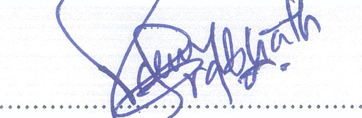 | 

